**Looking for a new challenge?**

As we continue to grow, we’re always looking for the very best people who can deliver work that bring our client’s visions to life and solves their equations. If you’re an ambitious, innovative & bright self-starter, we would like to hear from you.

**Freelance opportunities:**

We’re always keen on building new relationships with the very best freelance talent in East Africa. If that’s you, please get in touch and tell us what you can do.

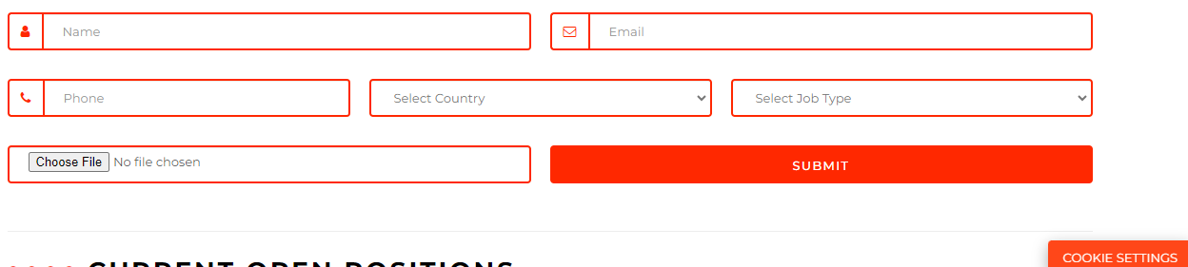

**GET IN TOUCH**

Let's meet your needs  
  
  
  
  
  
  
  
  
  
  
**Job Types**  
Designers

Data

Software  
Developer  
Installations

Database Administrator

Information Security Analysts

Computer Systems Analyst

Systems architect

Product Manager

Computer Network Architects

Systems Administrator  
Other